Closed Mixed Shapes
# Source: AI Source: Provided by: [Data Path: Persons Table -> ID Column: 1, Name_En Column: Motasem Essam] -> From: [ChatGPT] on [7/25/2026]
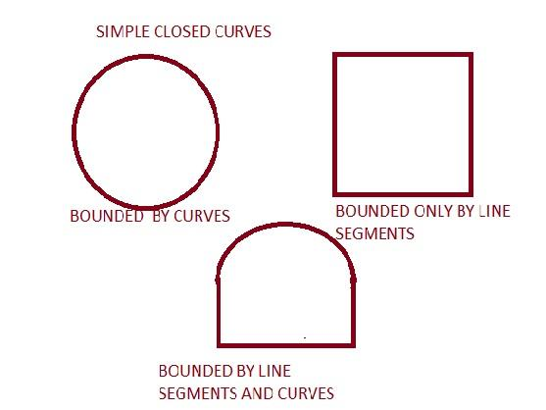
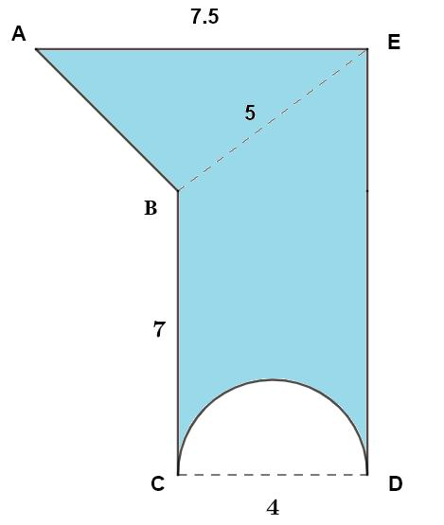
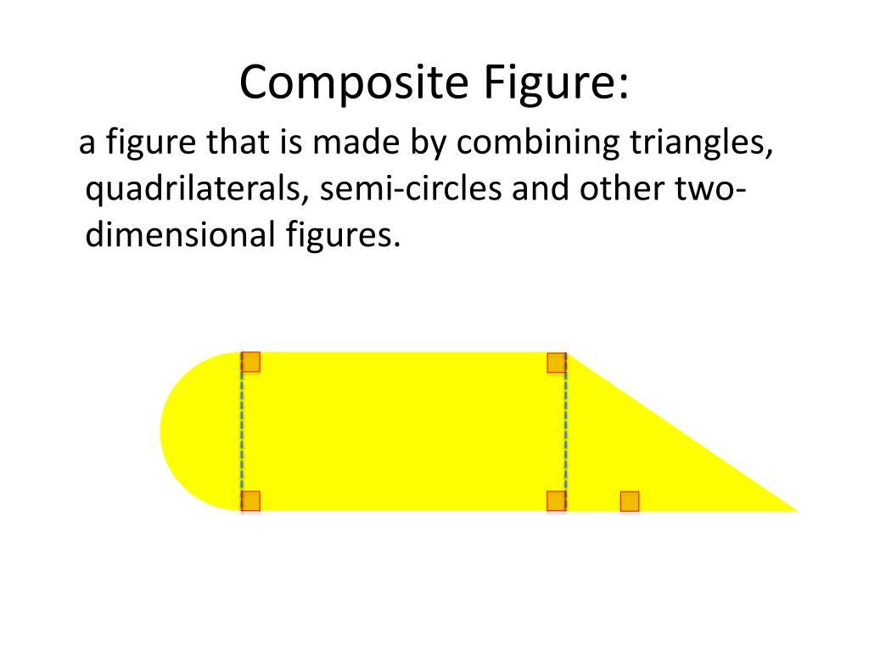
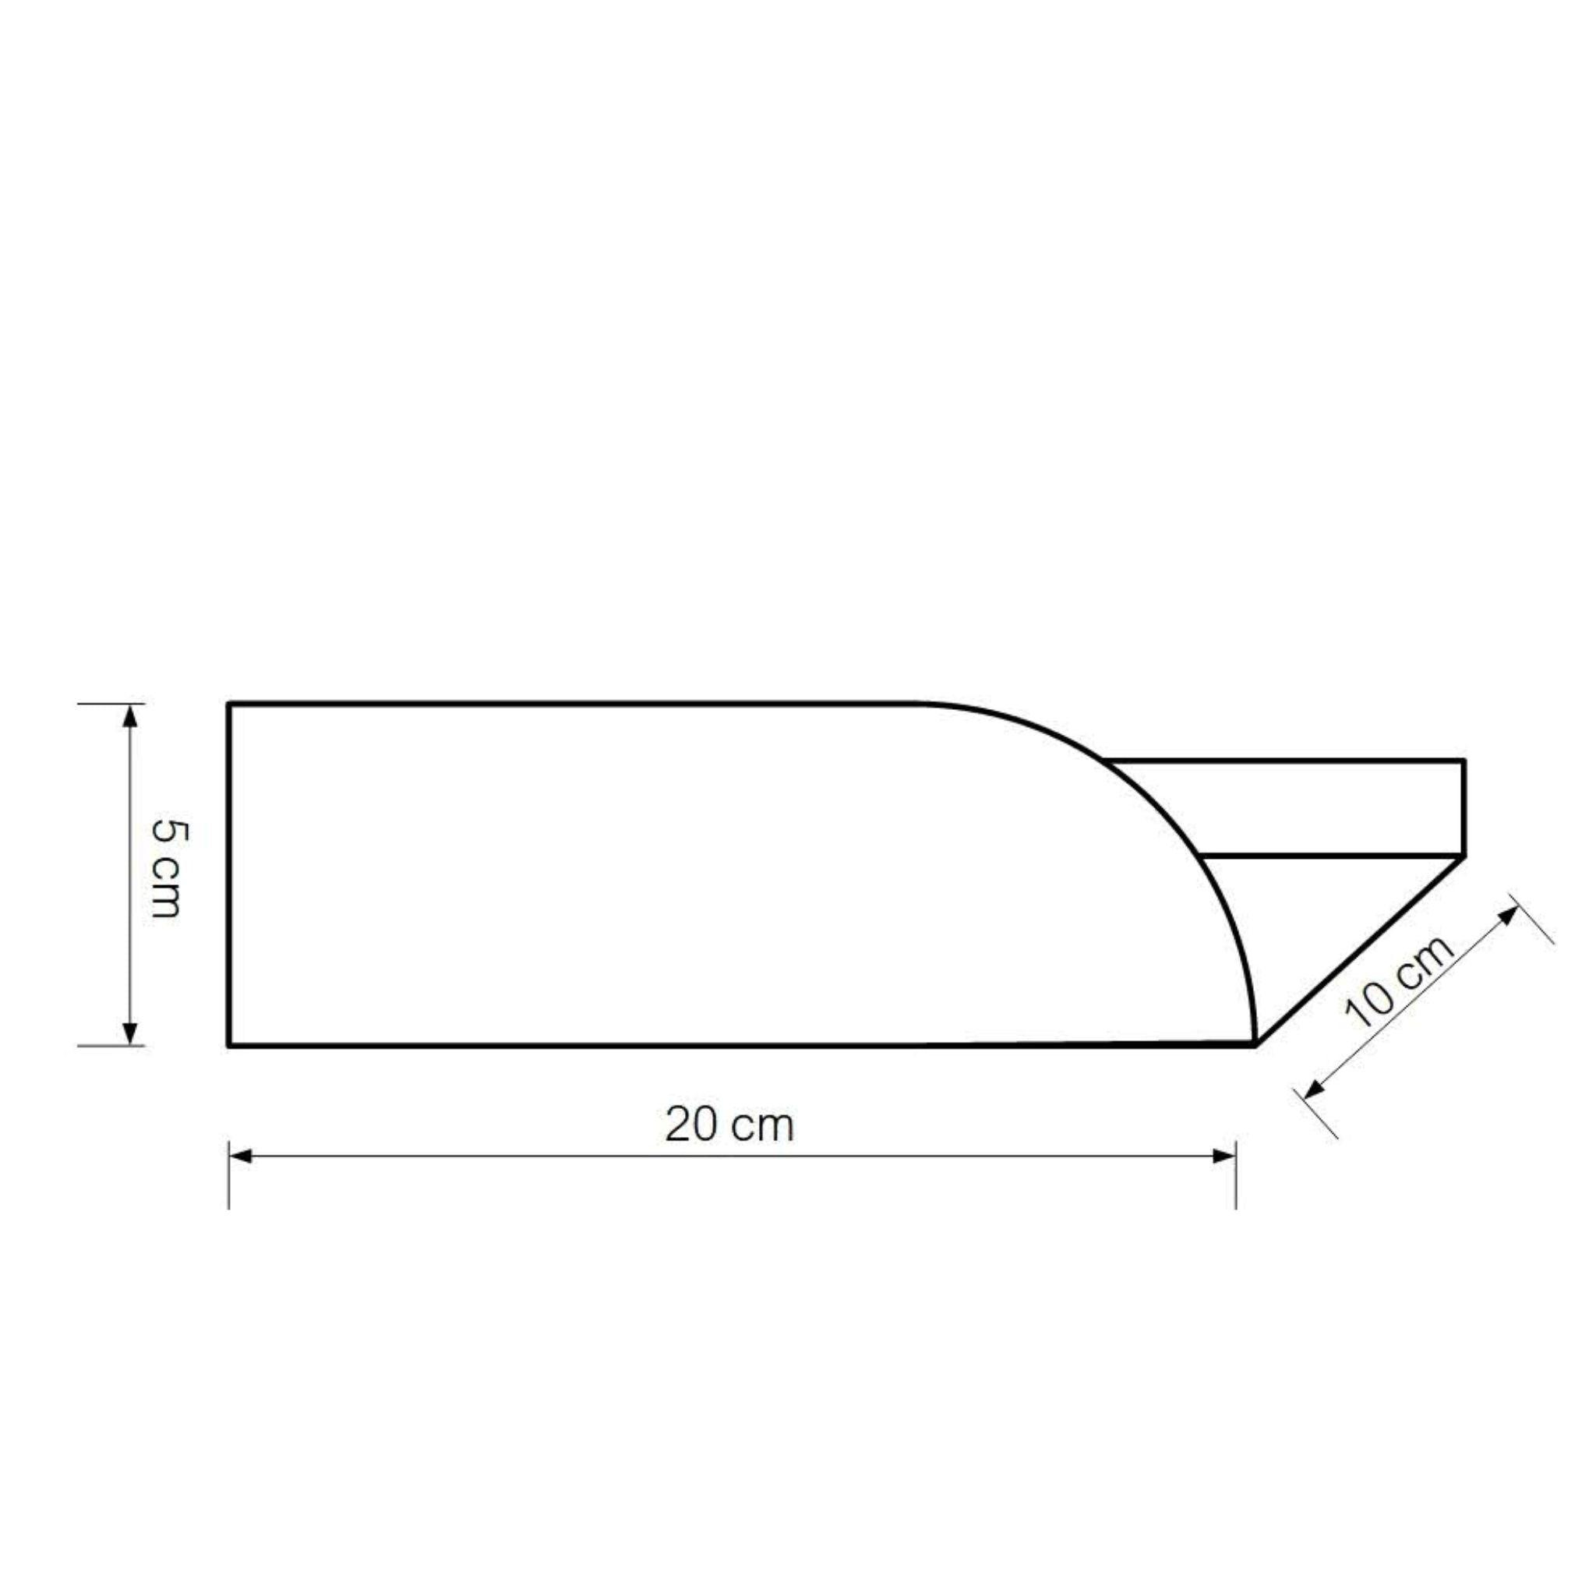

Definition
# Source: AI Source: Provided by: [Data Path: Persons Table -> ID Column: 1, Name_En Column: Motasem Essam] -> From: [ChatGPT] on [7/25/2026]
A Closed Mixed Shape is a closed plane shape whose boundary contains both straight and curved elements and returns to its starting point, enclosing a bounded region.
In simple terms:
It is a closed shape that combines polygonal and curved boundaries.
$$\boxed{\text{Closed Mixed Shape}=\text{Closed}+\text{Straight Boundaries}+\text{Curved Boundaries}}$$

Characteristics
# Source: AI Source: Provided by: [Data Path: Persons Table -> ID Column: 1, Name_En Column: Motasem Essam] -> From: [ChatGPT] on [7/25/2026]
A closed mixed shape typically:
- Is closed.
- Has no open endpoints.
- Encloses a bounded interior region.
- Contains at least one straight boundary segment.
- Contains at least one curved boundary.
- Has a mixed boundary.
- May combine polygons, circles, circular arcs, and freeform curves.
- Is often irregular.
- May be symmetric or asymmetric.
- Usually requires decomposition into simpler shapes for area or perimeter calculations.

Types of Closed Mixed Shapes

1. Polygon–Circular Closed Shapes
# Source: AI Source: Provided by: [Data Path: Persons Table -> ID Column: 1, Name_En Column: Motasem Essam] -> From: [ChatGPT] on [7/25/2026]
A polygonal component is combined with a circular component or circular arc.
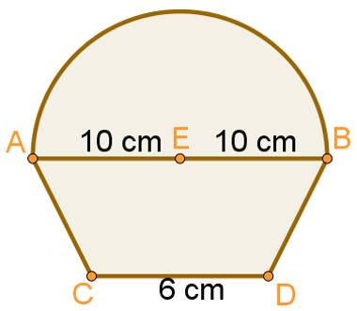
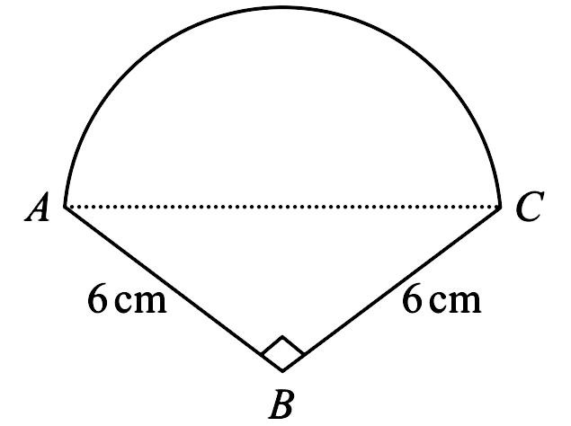
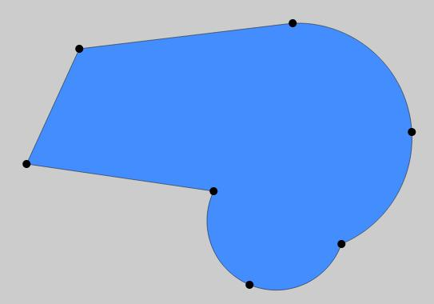
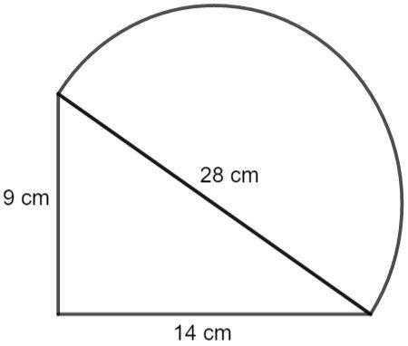
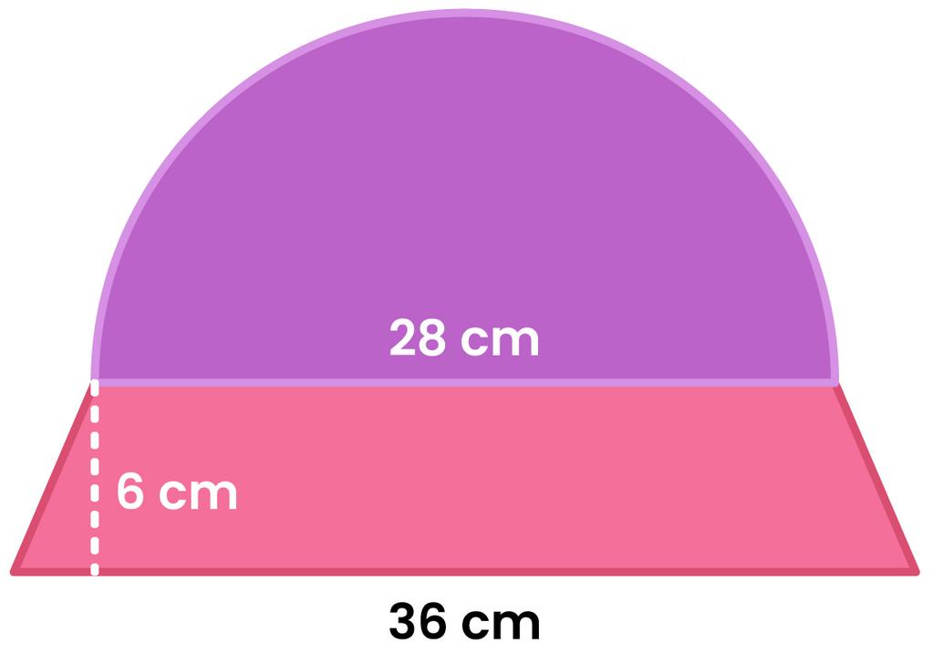
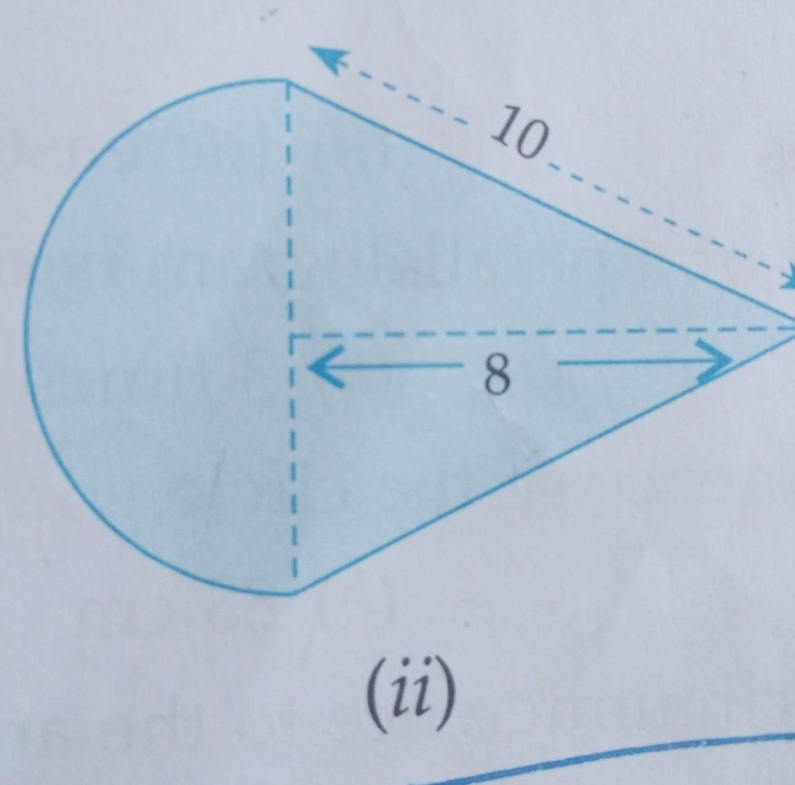
Examples:
- Rectangle + semicircle
- Triangle + semicircle
- Polygon + circular arc
- Polygon with circular cutout
$$\boxed{\text{Polygonal Part}+\text{Circular Part}}$$

2. Polygon–Organic Closed Shapes
# Source: AI Source: Provided by: [Data Path: Persons Table -> ID Column: 1, Name_En Column: Motasem Essam] -> From: [ChatGPT] on [7/25/2026]
A polygonal part is combined with an organic-looking curved part.
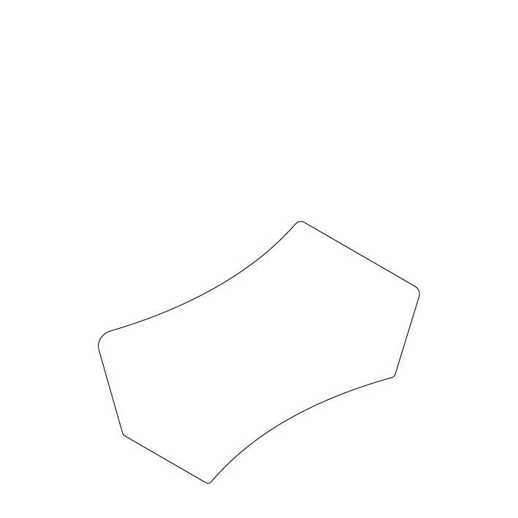
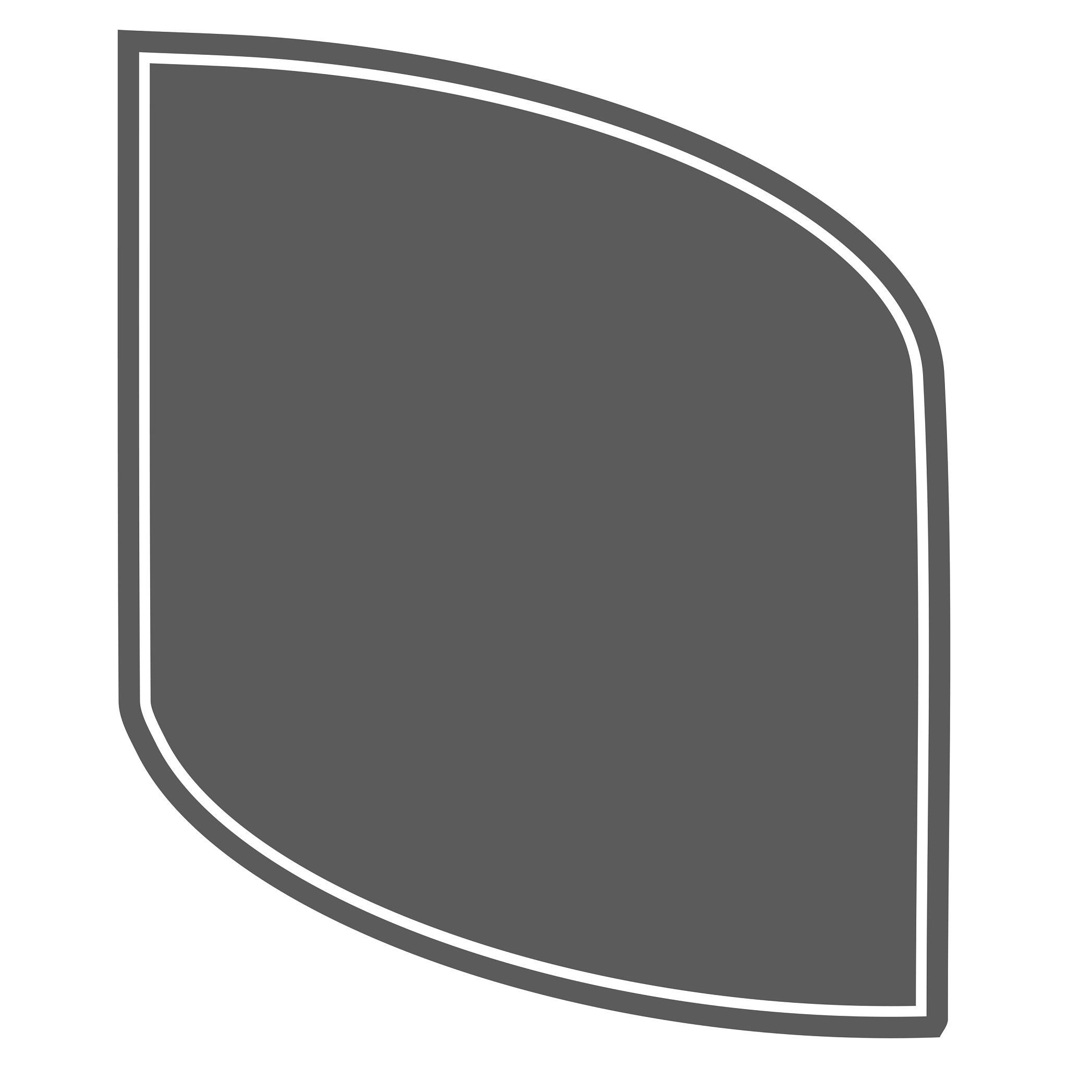
The curved component is not necessarily circular and may have variable curvature.
$$\boxed{\text{Polygonal Boundary}+\text{Organic Curved Boundary}}$$

3. Polygon–Freeform Closed Shapes
# Source: AI Source: Provided by: [Data Path: Persons Table -> ID Column: 1, Name_En Column: Motasem Essam] -> From: [ChatGPT] on [7/25/2026]
A polygonal component is combined with one or more freely controlled curves.
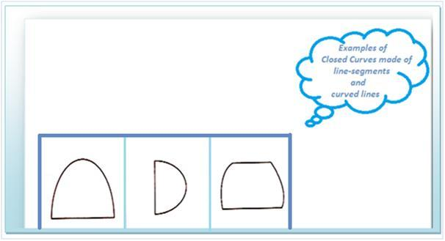
These shapes are common in:
- CAD
- Product design
- Architecture
- Computer graphics
- Illustration

4. Circular–Organic Closed Shapes
# Source: AI Source: Provided by: [Data Path: Persons Table -> ID Column: 1, Name_En Column: Motasem Essam] -> From: [ChatGPT] on [7/25/2026]
A circular component is combined with an irregular organic curve.
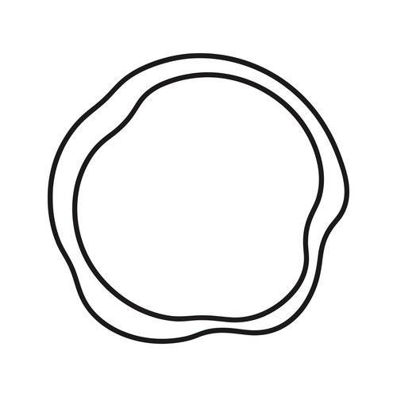
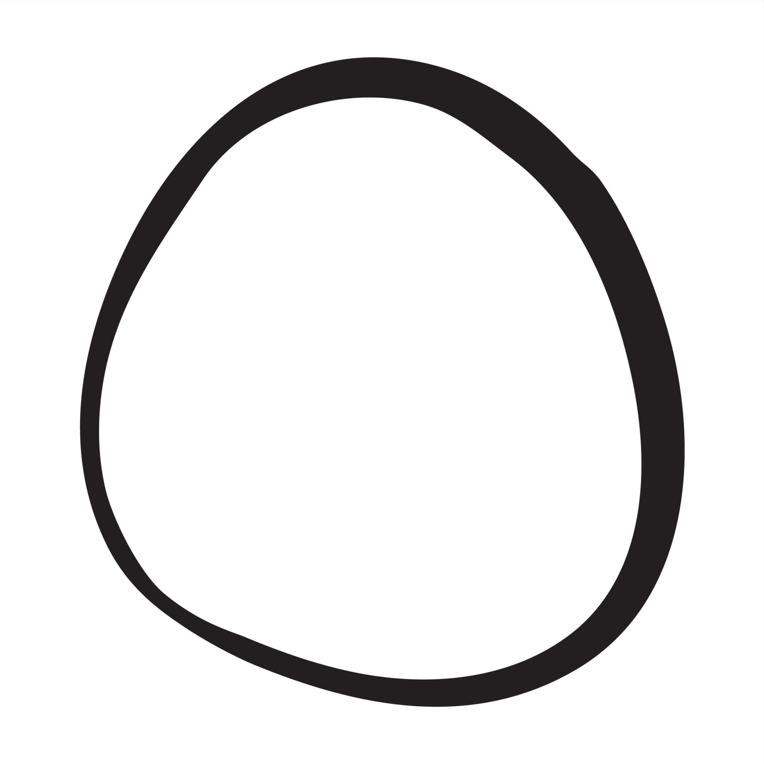
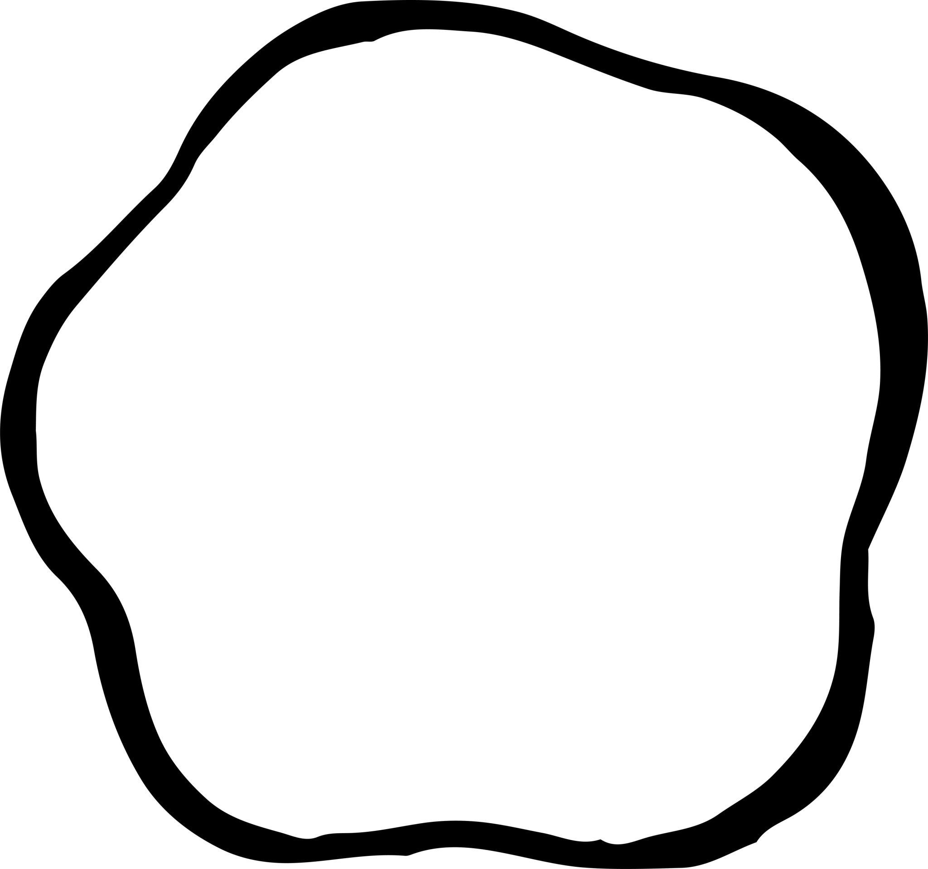
The boundary may contain both precise circular arcs and naturally flowing curves.

5. Circular–Freeform Closed Shapes
# Source: AI Source: Provided by: [Data Path: Persons Table -> ID Column: 1, Name_En Column: Motasem Essam] -> From: [ChatGPT] on [7/25/2026]
A circular component is combined with a freely designed non-circular curve.
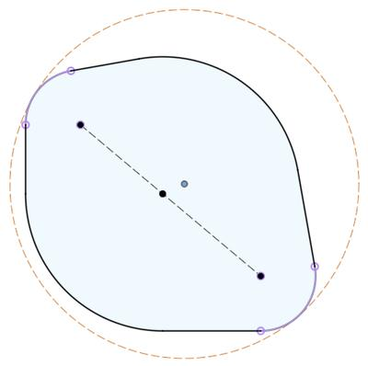
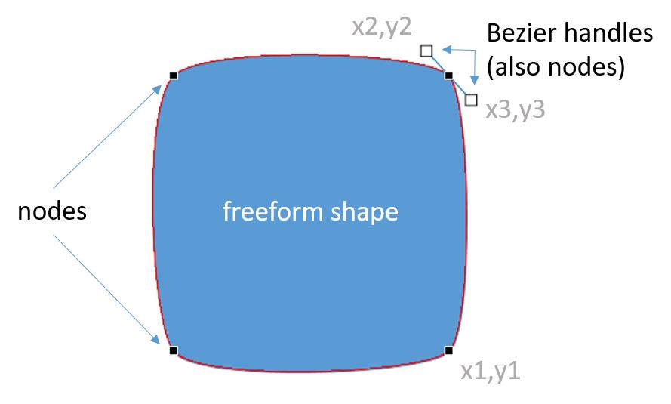
This type is common in custom engineering and graphic-design shapes.

6. Polygon–Circular–Freeform Closed Shapes
# Source: AI Source: Provided by: [Data Path: Persons Table -> ID Column: 1, Name_En Column: Motasem Essam] -> From: [ChatGPT] on [7/25/2026]
A complex closed shape can contain three different boundary types:
- Straight polygonal segments.
- Circular arcs.
- Freeform curves.
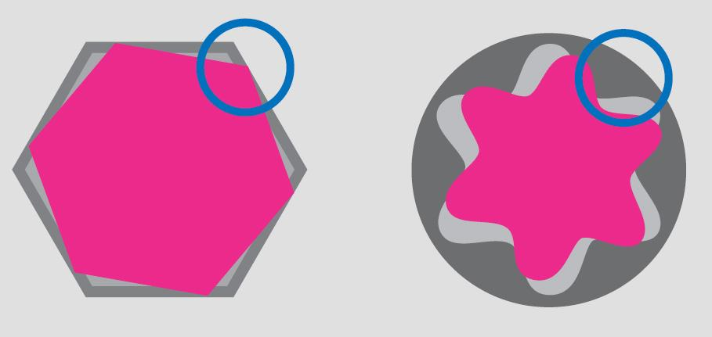
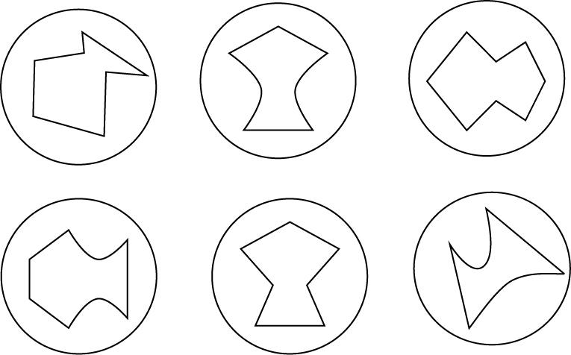
$$\boxed{\text{Polygon}+\text{Circular}+\text{Freeform}}$$

Boundary Classification
# Source: AI Source: Provided by: [Data Path: Persons Table -> ID Column: 1, Name_En Column: Motasem Essam] -> From: [ChatGPT] on [7/25/2026]
The defining characteristic is a mixed boundary:
$$\boxed{∂R=\text{Straight Segments}∪\text{Curved Segments}}$$
For example:
$$\boxed{\text{Mixed Boundary}=\text{Polygonal Segments}+\text{Circular Arcs}+\text{Freeform Curves}}$$
The exact combination depends on the shape.

Area
# Source: AI Source: Provided by: [Data Path: Persons Table -> ID Column: 1, Name_En Column: Motasem Essam] -> From: [ChatGPT] on [7/25/2026]
Because the shape is closed, it encloses a bounded region.
Its area can often be found by decomposition:
$$\boxed{A_{\text{total}}=\sum{A_{\text{added components}}}-\sum{A_{\text{removed components}}}}$$
For example, a rectangle with a semicircle attached:
$$A=lw+\frac{1}{2}πr^{2}$$
A rectangle with a circular hole:
$$A=lw-πr^{2}$$
For an arbitrary freeform component, numerical integration or coordinate-based methods may be required.

Perimeter
# Source: AI Source: Provided by: [Data Path: Persons Table -> ID Column: 1, Name_En Column: Motasem Essam] -> From: [ChatGPT] on [7/25/2026]
The perimeter consists of both straight and curved boundary lengths:
$$\boxed{P=\sum{L_{\text{straight}}}+\sum{L_{\text{curved}}}}$$
For a circular arc:
$$L_{\text{arc}}=rθ$$
where $θ$ is measured in radians.
For an arbitrary parametric curve:
$$\boxed{L=\int_{a}^{b}{\sqrt{{\left(\frac{dx}{dt}\right)}^{2}+{\left(\frac{dy}{dt}\right)}^{2}}}dt}$$

Closed Property
# Source: AI Source: Provided by: [Data Path: Persons Table -> ID Column: 1, Name_En Column: Motasem Essam] -> From: [ChatGPT] on [7/25/2026]
The curve returns to its starting point:
$$\boxed{P_{\text{start}}=P_{\text{end}}}$$
This distinguishes a closed mixed shape from an open mixed curve.
A closed mixed shape therefore has:
$$\boxed{\text{Interior}+\text{Mixed Boundary}+\text{Exterior}}$$

Closed Mixed vs. Closed Polygonal Shapes
# Source: AI Source: Provided by: [Data Path: Persons Table -> ID Column: 1, Name_En Column: Motasem Essam] -> From: [ChatGPT] on [7/25/2026]
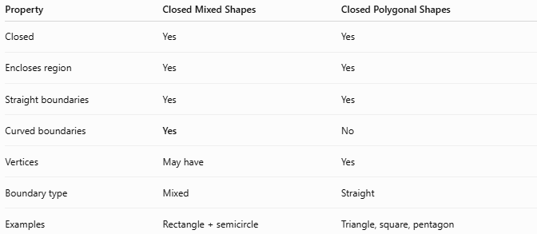
Property | Closed Mixed Shapes | Closed Polygonal Shapes
Closed | Yes | Yes
Encloses region | Yes | Yes
Straight boundaries | Yes | Yes
Curved boundaries | Yes | No
Vertices | May have | Yes
Boundary type | Mixed | Straight
Examples | Rectangle + semicircle | Triangle, square, pentagon

Closed Mixed vs. Closed Curved Shapes
# Source: AI Source: Provided by: [Data Path: Persons Table -> ID Column: 1, Name_En Column: Motasem Essam] -> From: [ChatGPT] on [7/25/2026]
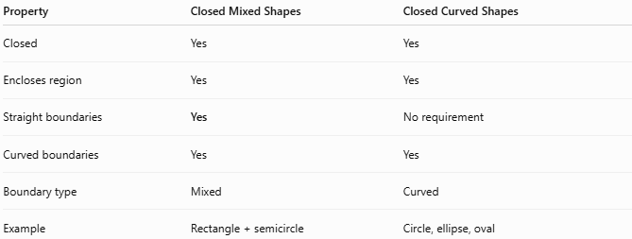
Property | Closed Mixed Shapes | Closed Curved Shapes
Closed | Yes | Yes
Encloses region | Yes | Yes
Straight boundaries | Yes | No requirement
Curved boundaries | Yes | Yes
Boundary type | Mixed | Curved
Example | Rectangle + semicircle | Circle, ellipse, oval
The key distinction is:
$$\boxed{\text{Mixed}=\text{Straight + Curved}}$$
while:
$$\boxed{\text{Curved}=\text{Curved Boundary}}$$

Key Points
# Source: AI Source: Provided by: [Data Path: Persons Table -> ID Column: 1, Name_En Column: Motasem Essam] -> From: [ChatGPT] on [7/25/2026]
A Closed Mixed Shape is:
$$\boxed{\text{Closed}+\text{Straight}+\text{Curved}}$$
It:
- Has a continuous closed boundary.
- Contains both straight and curved portions.
- Encloses a bounded region.
- Has an interior and exterior.
- Can contain polygonal, circular, organic, or freeform components.
- Can be regular in some components but irregular as a whole.
- Can often be measured by decomposing it into simpler shapes.

Conclusion
# Source: AI Source: Provided by: [Data Path: Persons Table -> ID Column: 1, Name_En Column: Motasem Essam] -> From: [ChatGPT] on [7/25/2026]
Closed Mixed Shapes are closed plane shapes that combine straight and curved boundary elements. They form a useful category between Closed Polygonal Shapes and Closed Curved Shapes. Examples include rectangle–circular, triangle–circular, polygon–organic, polygon–freeform, circular–organic, and circular–freeform shapes. Their area and perimeter are generally determined by separating the shape into simpler components and combining the corresponding measurements.

